

Open a terminal on your Kali Linux system.

$ sudo apt-get install snort

$ cd /etc/snort

$ sudo mousepad snort.conf

To change your HOME_NET with your ip address

-> ipvar HOME_NET 192.168.86.128/24

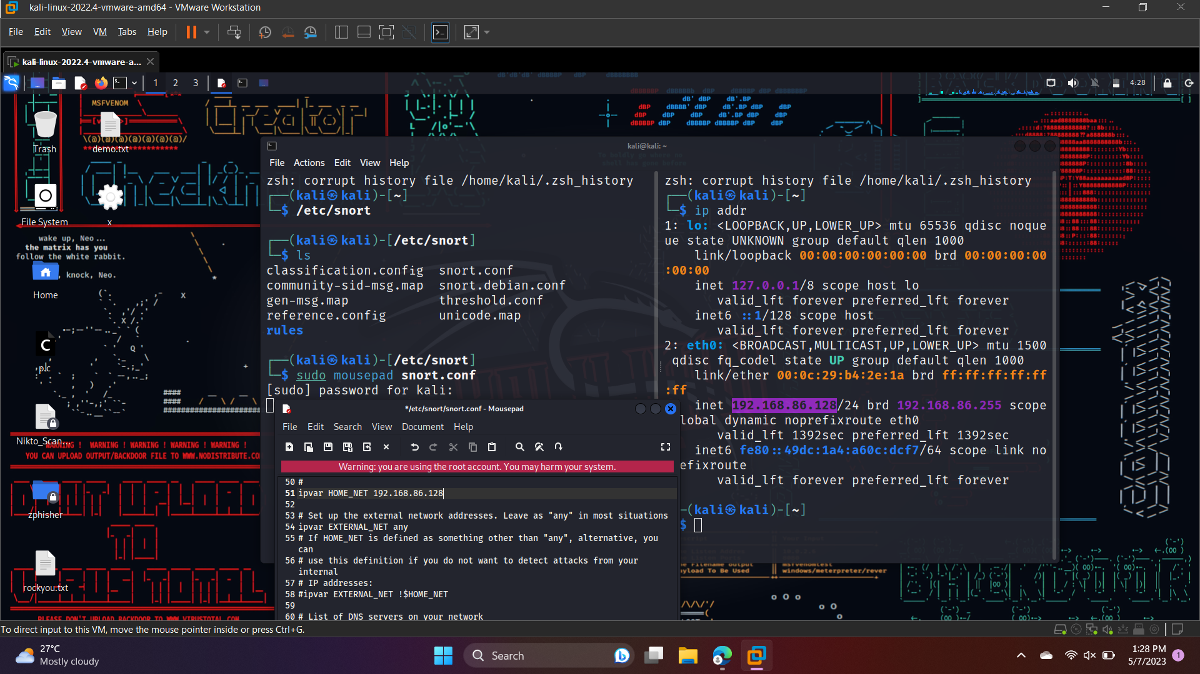

$ ip addr

To know your ip address



**Snort Rules**

Snort is a signature-based IDS, and it defines rules to detect the intrusions. All rules of Snort are

stored under **/etc/snort/rules** directory. The screenshot below shows the files that contain rules of Snort.

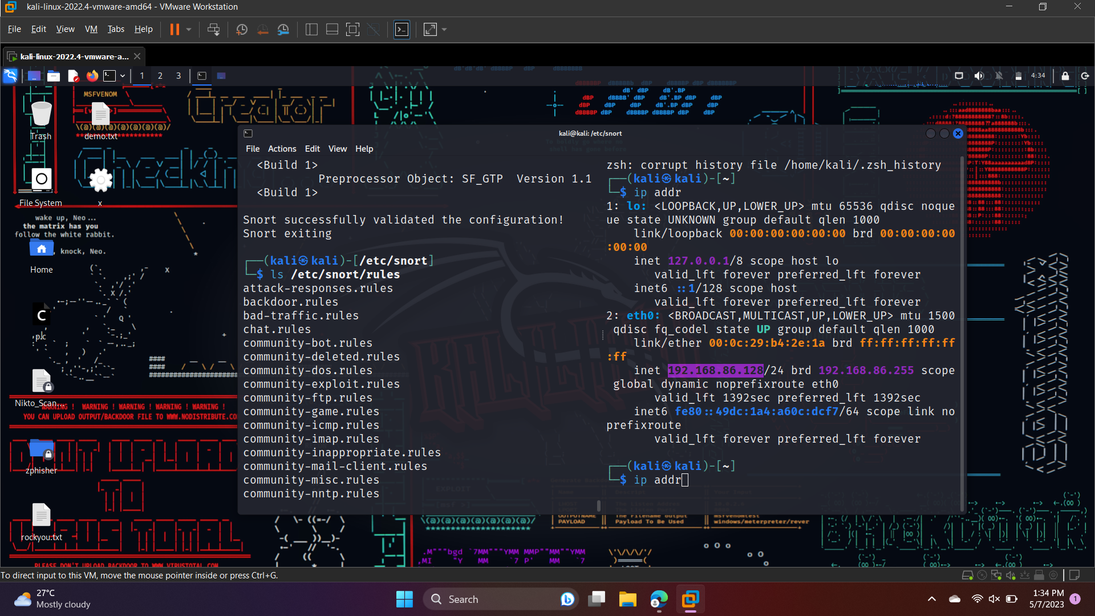

**$** **cd /etc/snort/rules**

**$ sudo mousepad local.rules**

In rule file write a rule so that Snort will generate an alert.

**alert icmp any any -> $HOME_NET any (msg:"Testing ICMP alert"; sid:1000001; rev:1;)**

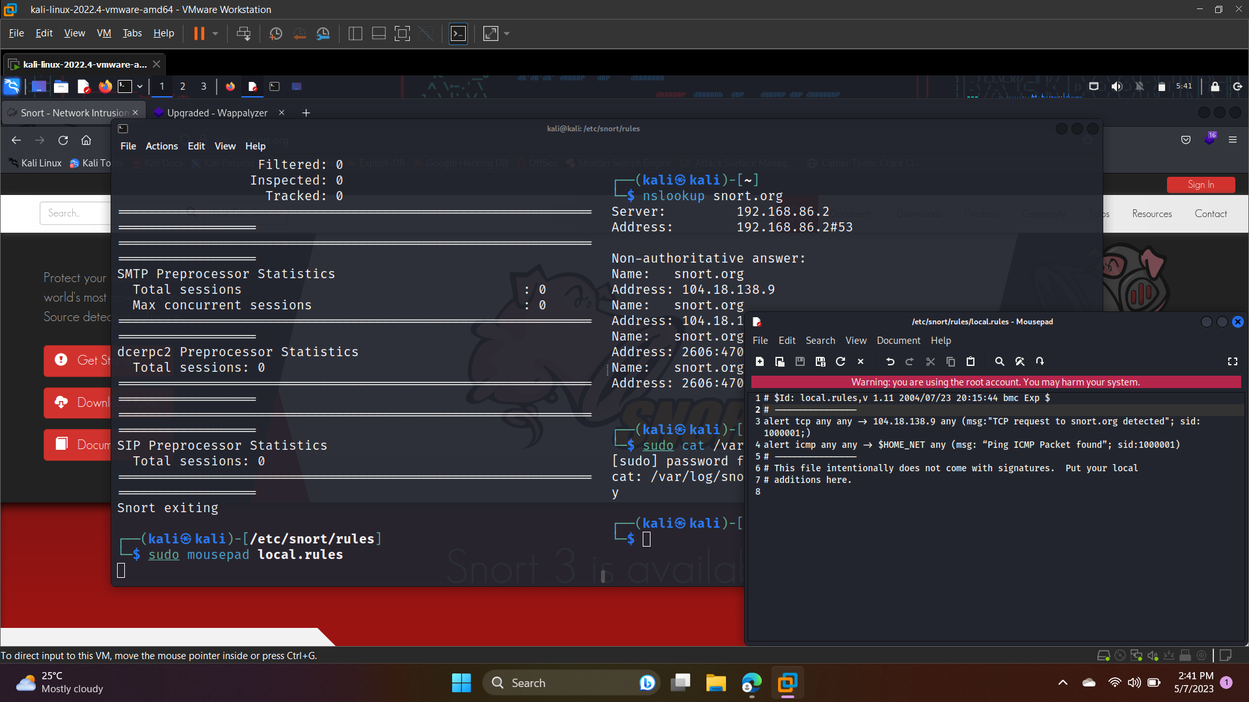

**Here are some available actions in Snort rules with their syntax:**

**1. Alert: Generates an alert message and logs it to the specified output plugin.**

**Syntax:**

alert tcp any any -> any 80 (msg:"Web traffic detected"; sid:1000001; rev:1;)

**2. Log: Logs the packet to the specified output plugin.**

**Syntax:**

log icmp any any -> any any (msg:"ICMP traffic detected"; sid:1000002; rev:1;)

**3. Pass: Ignores the packet, allowing it to pass through the network.**

**Syntax:**

pass udp any any -> any any (msg:"UDP traffic detected"; sid:1000003; rev:1;)

**4. Activate: Enables a specified dynamic rule when the current rule is triggered.**

**Syntax:**

alert tcp any any -> any 22 (msg:"SSH traffic detected"; sid:1000004; rev:1; activate:1000005;)

**5. Dynamic: Specifies a dynamic rule, which is created and enabled when the rule is triggered.**

**Syntax:**

dynamic tcp any any -> any any (msg:"TCP traffic detected"; sid:1000005; rev:1;)

**6. Drop: Drops the packet, preventing it from continuing through the network.**

**Syntax:**

drop tcp any any -> any 23 (msg:"Telnet traffic detected"; sid:1000006; rev:1;)

**Note that there are many other actions available in Snort, and the specific syntax and options may vary depending on the output plugin and configuration settings.**

**Again, run the validation command to validate the configuration.**

$ sudo snort -T -I ens33 -c/etc/snort/snort.conf

**It should say:**

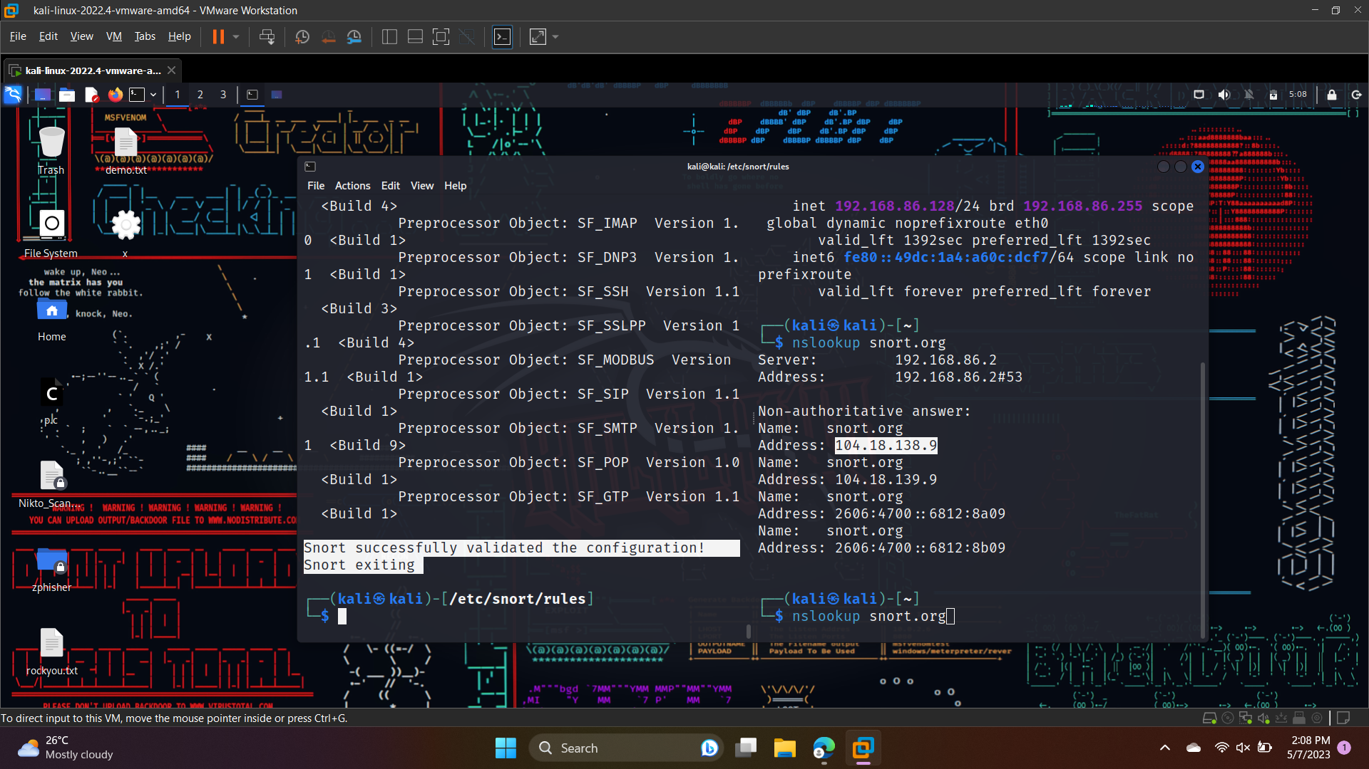

**Here's a breakdown of the syntax:**

* "icmp" specifies the protocol to monitor.
* "any" indicates the source IP address and port number, while "any" after "->" indicates the destination IP address and port number.
* "msg" specifies the message you want to include in the alert.
* "sid" specifies the unique ID for the rule.
* "rev" specifies the rule revision number.

In Snort, you can use either "any any" or just "any" to specify any source IP address and any source port number.

When you use "any any" in a Snort rule, it means that the rule will match traffic from any source IP address and any source port number. For example, if you specify "any any" in the source address and source port fields of a rule, it will match traffic from any IP address and any port number.

When you use "any" in a Snort rule, it means that the rule will match traffic from any source IP address, but the source port number can be any port number greater than 1024. For example, if you specify "any" in the source address field and "80" in the source port field of a rule, it will match traffic from any IP address with a source port number greater than 1024 that is destined for port 80.

**Some Demo tasks**

**Question No. 1: Write and add another snort rule and show me you trigger it.**

a. The rule you added (from the rules file)

alert icmp any any -> $HOME_NET any (msg: “Ping ICMP Packet found”; sid:1000001)



**b. A description of how you triggered the alert**

To trigger this alert, you can ping a machine on your network from another machine. For example, if you have two machines on your network with IP addresses 192.168.1.10 and 192.168.1.20, you could ping 8.8.8.8 from **HOME_NET** to generate an ICMP echo request from This should match the rule you provided and generate an alert.

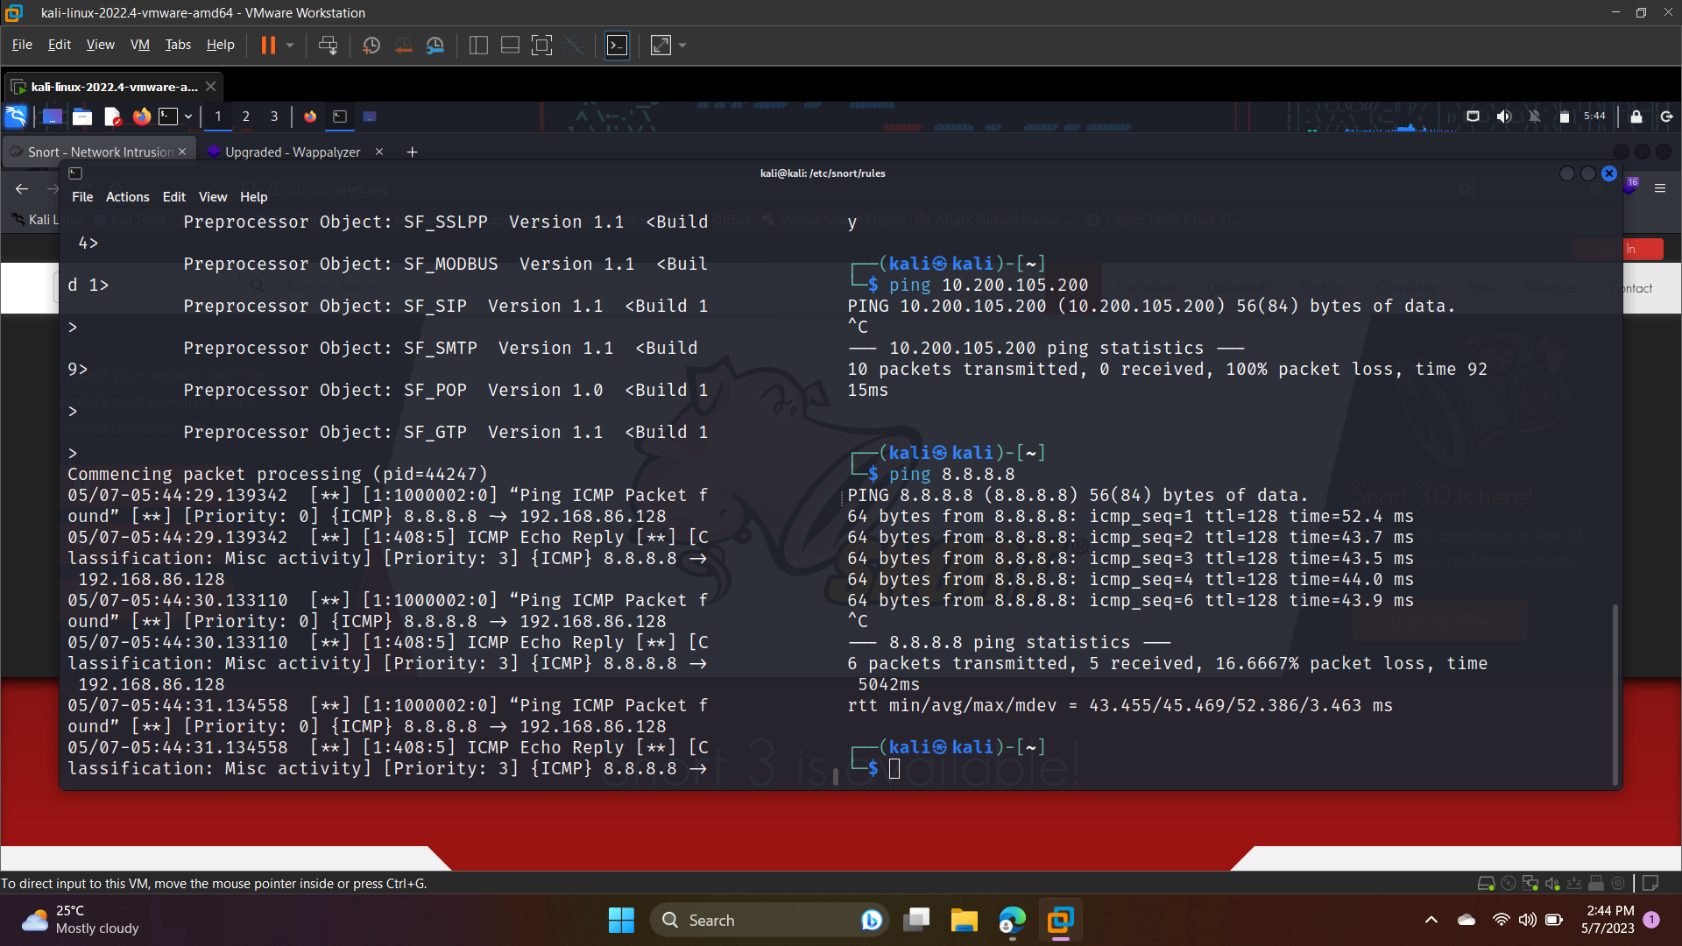



**Question No. 2: Write a rule that will fire when you browse to snort.org from the machine Snort is running on; it should look for any outbound TCP request to snort.org and alert on it.**

alert tcp any any -> snort.org 80 (msg:"Outbound TCP request to snort.org detected"; sid:100002; rev:1;)

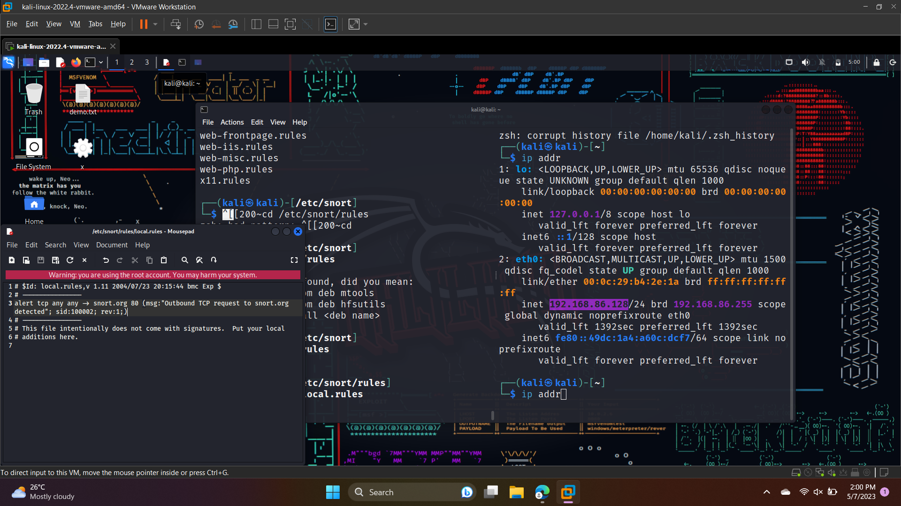

**In my case:**

alert tcp 192.168.86.128 80 -> snort.org 80 (msg:"Outbound TCP traffic to snort.org:80 detected"; sid:1000005; rev:1;)

**For Checking if rule has been save successfully?**

$ sudo snort -T -I ens33 -c/etc/snort/snort.conf

Initializing rule chains...

ERROR: /etc/snort/rules/local.rules(3) Unable to process the IP address: snort.org.

Fatal Error, Quitting..

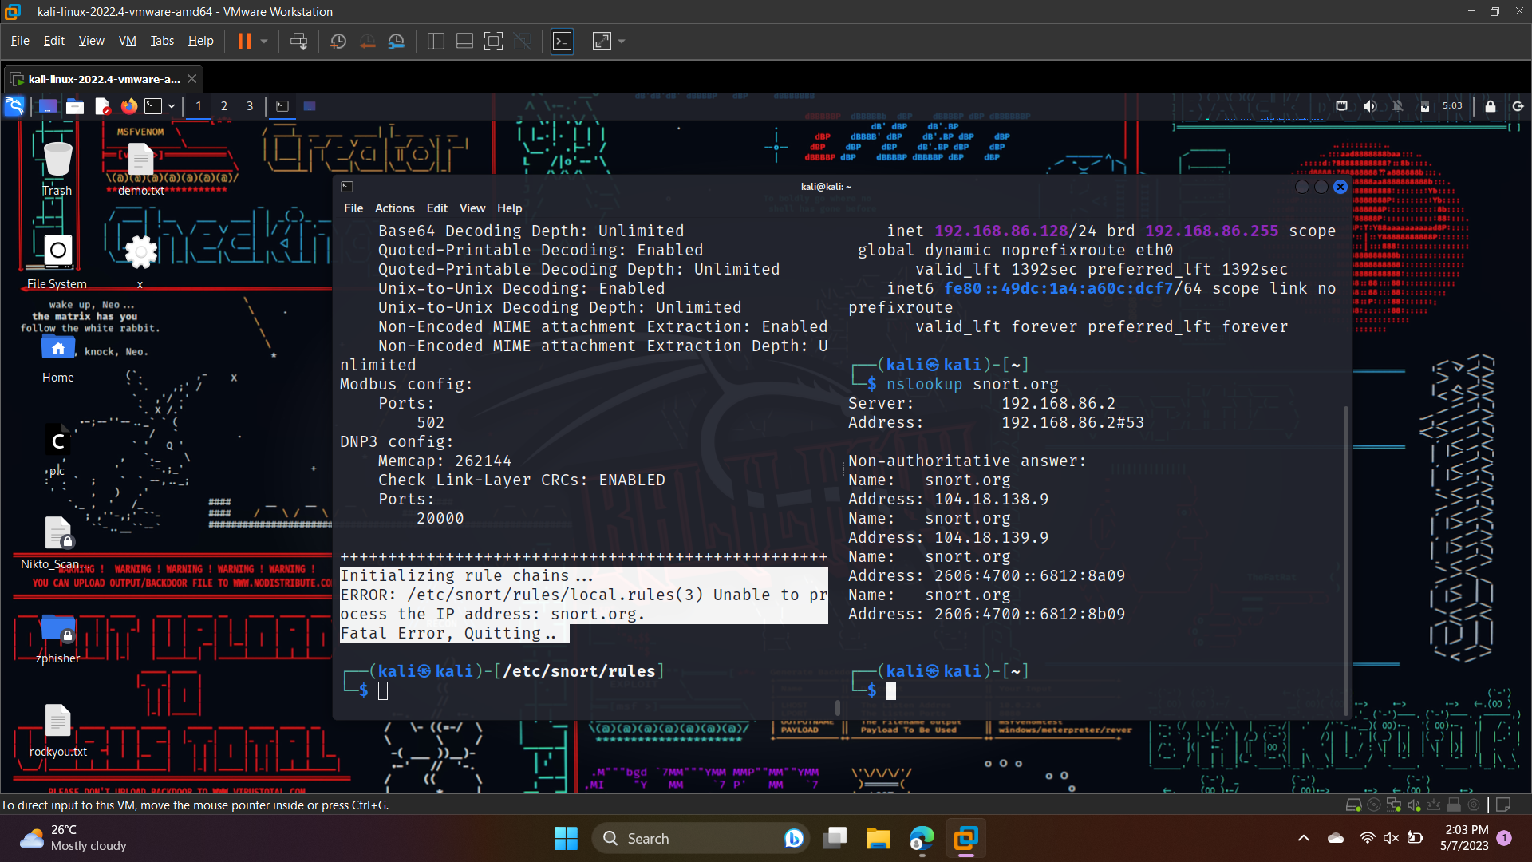

**To see ip for snort.org**



**Change snort.org with ip**

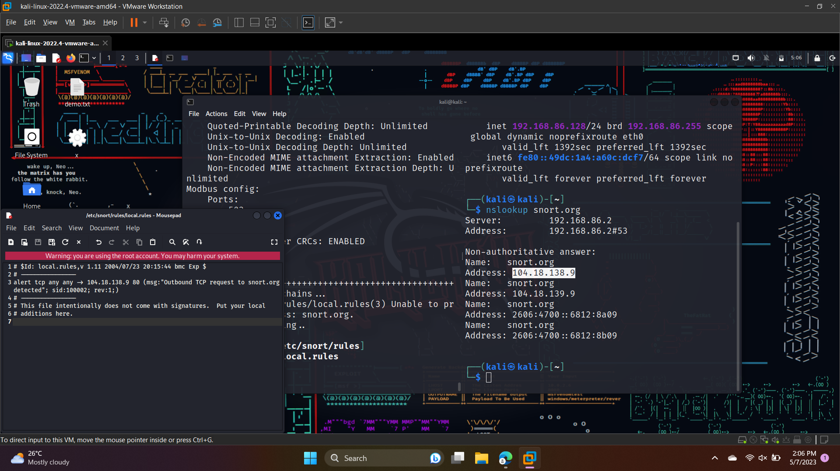



Now it says **Snort successfully validated the configuration!**

**Snort exiting**

**To run:**

**sudo snort -i <interface> -c <config-file>**

* **-i <interface>** specifies the network interface that Snort should listen on. For example, if you want Snort to listen on the eth0 interface, you would use -i eth0.
* **-c <config-file>** specifies the path to the Snort configuration file. By default, the configuration file is located at /etc/snort/snort.conf.

**To check detection live:**

**$ sudo snort -i eth0 -c /etc/snort/snort.conf -A console**

And i visited ip address i got through nslookup of snort.org, Here are detection ss:

